
On-Line Bill Setup Instructions

This document provides step-by-step instruction on how to set up on-line access to your Lackawaxen account. This is a two-step process. The first step creates your on-line account and the second step activates it. Once your on-line account has been established, it is possible to stop receiving a paper copy of your bill each month, if you choose to do so. Instead of a paper bill, you will receive an e-mail notification that your bill is available at the on-line site.

Before you begin, make sure you have a copy of your last telephone bill from Lackawaxen. You will need information from this bill to create your e-bill account. To create and activate your on-line account, perform each of the following steps:

# | Step
1 | Access the Internet using a web browser such as Internet Explorer You can do this using any computer connected to the Internet. You do not have to do it from your Lackawaxen Internet connection.
2 | Go to Lackawaxen's web site home page at http://www.ltis.net
3 | Click where it says "View My Bill". This link is in the far left column of the home page. Clicking this will take you to the login page of Lackawaxen's secure e-billing site. If you already have an e-bill username and password, enter them in the appropriate boxes on this screen and click the "Log In" button. This will access your account information. If you do not have an e-bill username and password, you must create a new login. (view image)
4 | Click where it says "create a new login" This will direct you to the Create Account screen where your e-bill username and password are created. (view image)
5 | You must now fill in the fields on this form: (view image)
6 | Full Name: | Enter the full name that is shown as the account name on your telephone bill
7 | Preferred Username: | This can be any name you want such as your first name, a nickname, your last name, or your first and last name together.
8 | Preferred Password: | This can be any combination of letters, numbers, and symbols, but it must be at least 6 characters in length.
9 | Verify Password: | You must enter the exact same password you entered in the Preferred Password field for verification that you typed it correctly.
10 | E-Mail Address: | Enter an email address that the e-bill system will use to send you information. This can be any e-mail address you would like. It does not have to be your Lackawaxen e-mail address.
11 | Choose a password hint question: | This question will be used to help verify you if you forget or lose your password. Select one of the questions from the drop-down selection box.
12 | Hint Answer: | Enter the answer to the password hint question that you selected in the previous step.
13 | Invoice Number: | Enter the "invoice number" exactly as it appears on your last telephone bill from Lackawaxen. Remember, you must enter the "invoice number", not the account number nor the telephone number. The link on the screen labeled "Invoice Number and Invoice Total location" will show you where the invoice number is located on your bill.
14 | Latest Amount Due: | Enter the latest "amount due" exactly as it appears on your last telephone bill from Lackawaxen. The link on the screen labeled "Invoice Number and Invoice Total location" will show you where the latest amount due is located on your bill.
15 | Once you have filled in all the information, click the "Create Login" button
16 | You will then see the "Account Created Successfully" screen. This completes only the first portion of the registration process. You cannot login to the e-bill system until you complete the process. The e-bill system will send you a confirmation e-mail shortly. (view image)
17 | Log in to the e-mail account you specified during the first part of the process. You should see an e-mail message in your inbox from ltis@ltis.net, with the subject line "Confirm Registration" (view image)
18 | Open the e-mail message. You will see a message thanking you for registering with e-bill, and indicating that your account has been 'created' but not 'activated'. To activate your account, you must click on the link at the end of the e-mail message. It will probably be a different color, underlined, and begin with http://ltsapweb/ebpp/AccountManage/ConfirmEmail followed by a group of numbers. You must click this link. (view image)
19 | When you click this link, you will return to the e-bill site and see the "Email Confirmation" screen. (view image)
20 | Click on the button labeled "Confirm". You will then receive the email confirmation screen containing a statement that says: "Email Successfully Confirmed". Your account is now activated. (view image)

Once your e-bill account has been created and activated, you can access your account by going to the Lackawaxen home page at http://www.ltis.net and clicking where it says “View My Bill”. You may then log into your account by entering your username and password.

If you have any questions, please contact our business office at 570-685-7111.

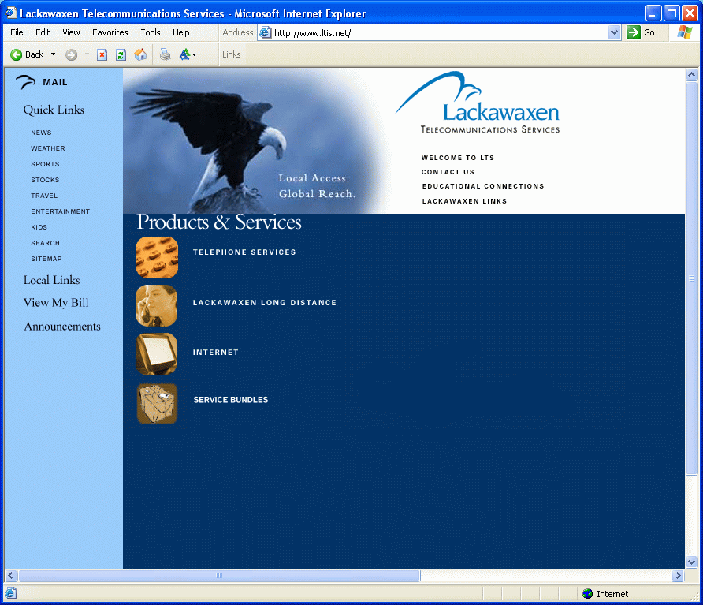

(back to instructions)
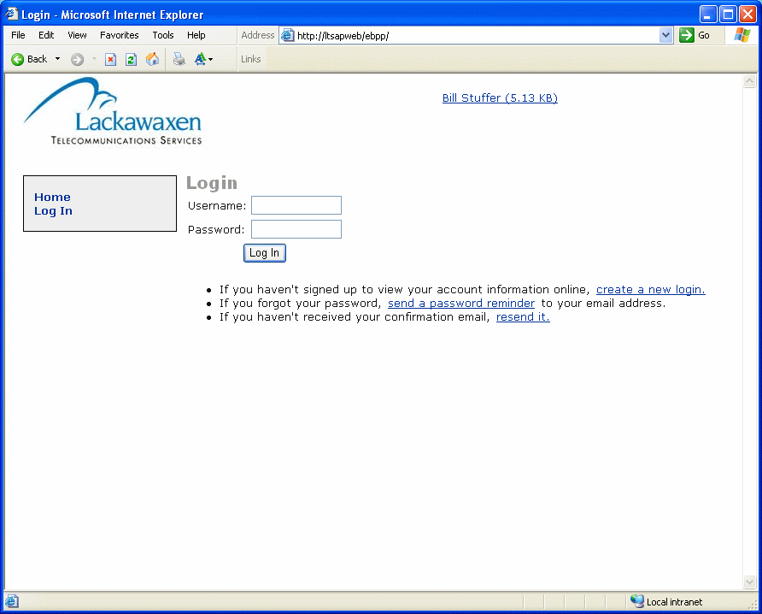

(back to instructions)

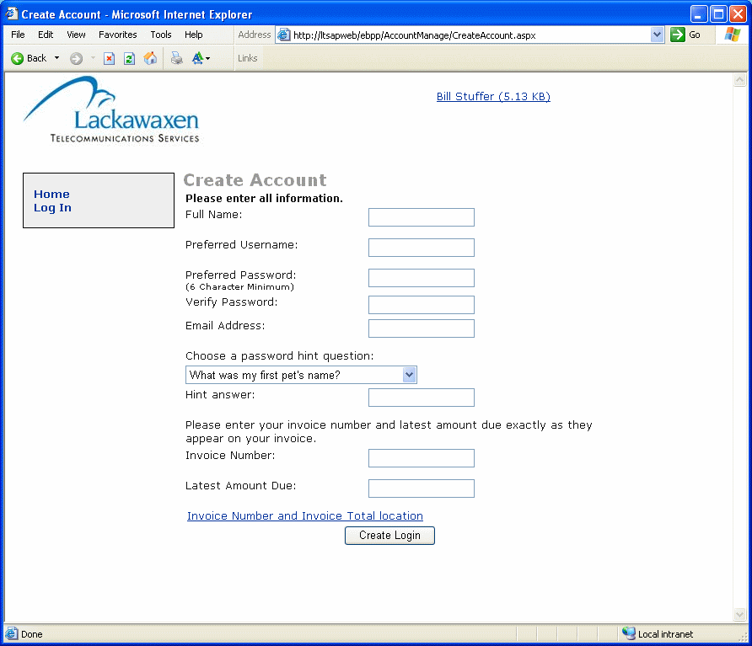

(back to instructions)

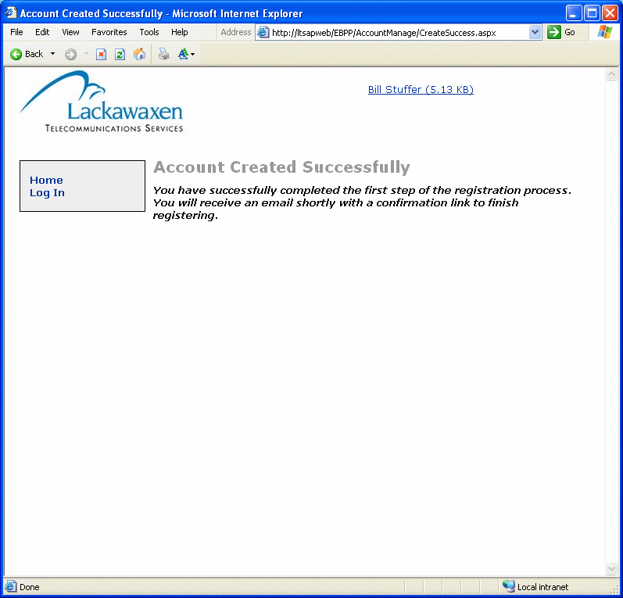

(back to instructions)

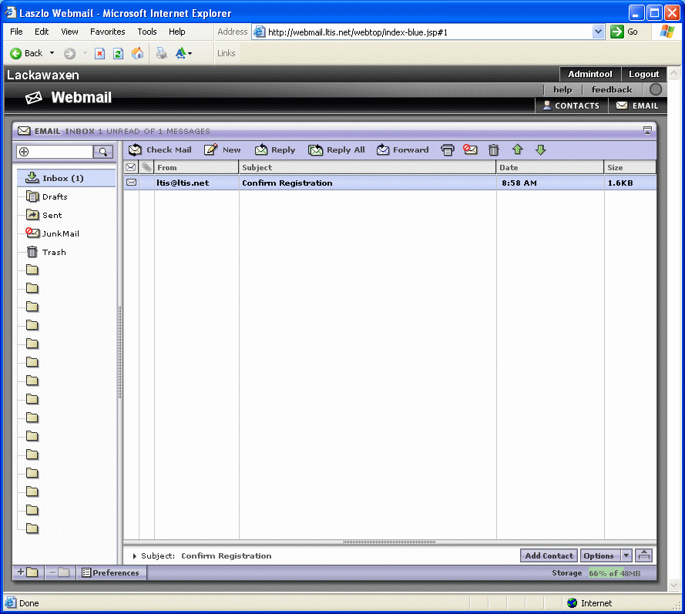

(back to instructions)
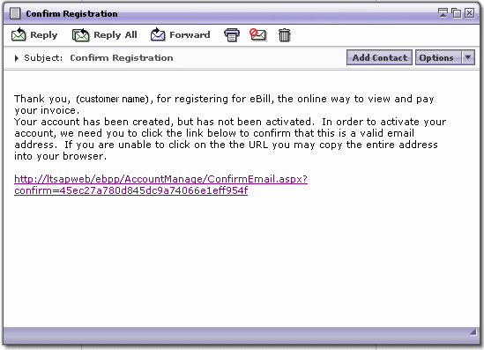

(back to instructions)
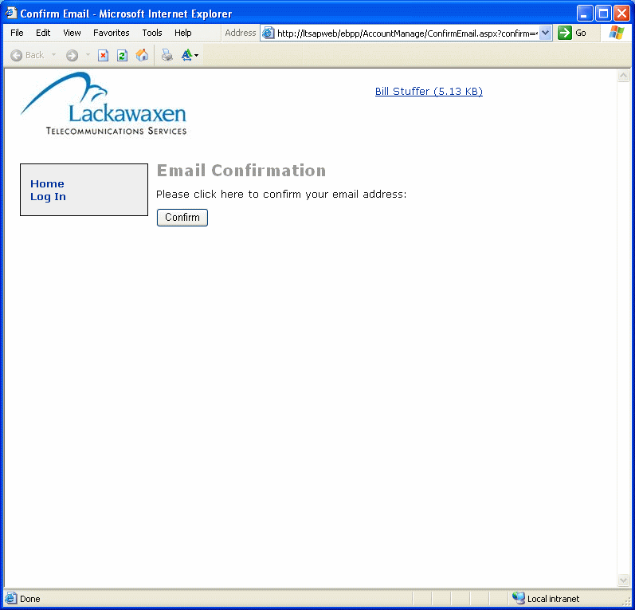

(back to instructions)
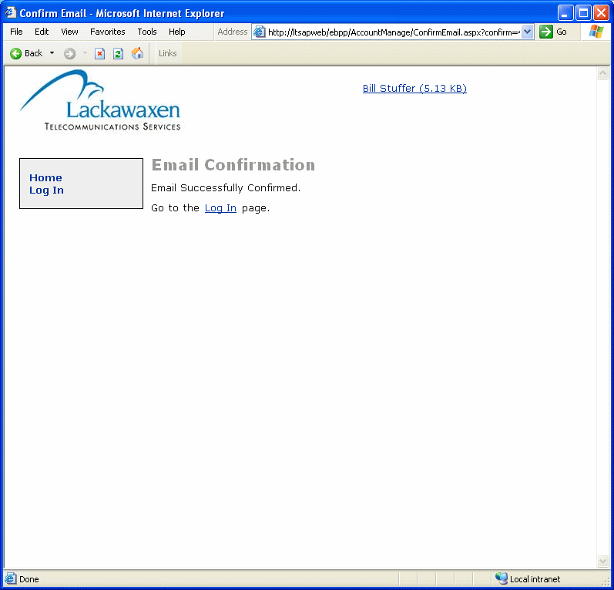

(back to instructions)

